LAB 1, INTRODUCTION TO C# AND VISUAL STUDIO

# Lab 1, Introduction to C# and Visual Studio

# 

## Objective

In this lab you will

* Create a Console program using the Visual Studio IDE
* Run the program

## Overview

Visual Studio is the development tool used by many C# developers and throughout this course. This lab will show you how to create and run a C# program.

## Step by step

### Creating a new C# application

1. Launch Visual Studio and create a new Project.

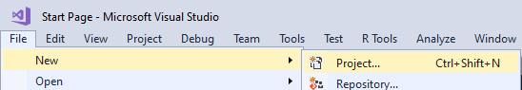

1. Select the Windows Desktop->Console App from the list



1. Type *"****Lab01****"* as the Name for this project.
2. Take a note of the location where this project will be saved.

Please note, Visual Studio has created a class called ***Program*** with a special method called **Main()** which runs when you execute the code.

### Writing the Code

1. In the Program class's main method type the following:

**using System;**

**namespace Lab01**

**{**

**class Program**

**{**

**static void Main(string[] args)**

**{**

**Console.WriteLine("Hello World!");**

**}**

**}**

**}**

Please note, the **namespace** for this class is "Lab01". You can change this name if you like. A class does not have to be placed inside a namespace but it helps as you'll see later on in this course.

### A couple of useful editor command

1. In the line below the **Console.WriteLine**, type ‘**cw**’ and then hit the tab key twice to auto type the statement Console.WriteLine().   
   Type another message in the second Console.WriteLine statement.
2. Type the following text (in lowercase) in your program   
   console.writeline("Hi");

The editor display red lines under the statement indicating errors.

1. Click on the word system and then press Ctrl-space keys to auto-correct the text. Do the same for "writeline".
2. On a separate line type the word "File". Click on this word and then press the Ctrl-. (Control dot) keys together. The editor will then display:

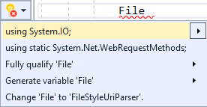

Select the first line (using System.IO;) to include this line at the top of the file.  
Press a dot after the word File to see methods of the File class. We will talk about the File class later on in this course.

1. Click on the last line (File...) and then press **Ctrl-c** to copy the entire line
2. Press **Ctrl-v** to paste the line.
3. Highlight the last two lines and then press **Ctrl-kc** to comment the lines out
4. With the last two lines highlighted, click **Ctrl-ku** to uncomment the lines.
5. With the last two lines highlighted, click **Ctrl-kx** to copy the lines and delete them.
6. Another very important editor feature is the auto-format command.   
   Try moving a few lines of code to the left by deleting the spaces and then press the **Ctrl-kd** keys together to format the page.

**Make sure you use these time saving editor command.**

### Building and running the program

1. Save your code by pressing Ctrl-s.
2. Press **Ctrl+F5** to compile and run the program or click the green Run icon.
3. A Console window will pop up and displays the messages in your program.
4. Sometimes it is useful to just compile your project without running it. For example when you want to discover any compilation errors.   
   Press **Ctrl-Shift-b** to build your project.

** End **